SUPERVISION
Date / time: 06/11/2025

Main issues discussed
- Experimental and Research Roadmap. My experimental workflow is feasible and sound. The negative results from model combination/ensembling are also valuable.
- It is acceptable to continue using Colab, because everyone has a licence.
- It is acceptable to include some of the thought process in the project process.
- Explanatory power and theoretical depth. A strong project should explain, not just describe: it needs to clearly articulate the algorithms and mechanisms
- Transcribing meetings is a good practice.

Work shown
- Performance of KNN, Random Forest, InceptionTime, MiniRocket, MultiRocket, and TST on the RealWorld dataset, and comparison of the estimated energy consumption of the six models.
Answer: First provide a systematic explanation of the baseline performance.
Me: MiniRocket has the best overall performance when considering accuracy, model size, inference latency, and energy consumption.
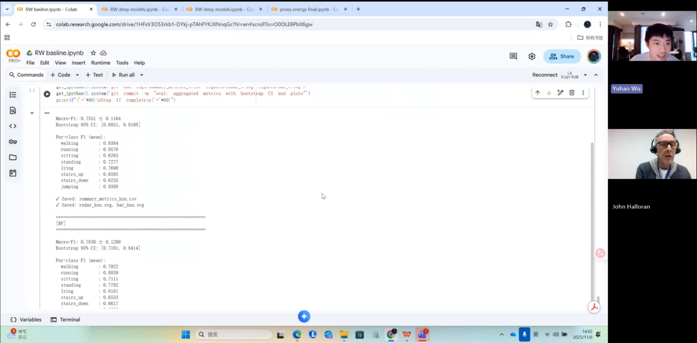

- The complete experimental workflow. Plan to exclude multirocket because it cost lots of time to train.
Answer: Do not eliminate models too early; you should explore the possibilities of different combinations. Weak models may still be valuable and can potentially be improved when integrated with other models.
The experimental workflow you presented is feasible and looks good. What will your next steps be?
Me: If possible, I plan to add one or two more state-of-the-art models, but not too many; the main focus will be on explaining how the models work and providing in-depth analysis.
Answer: Good

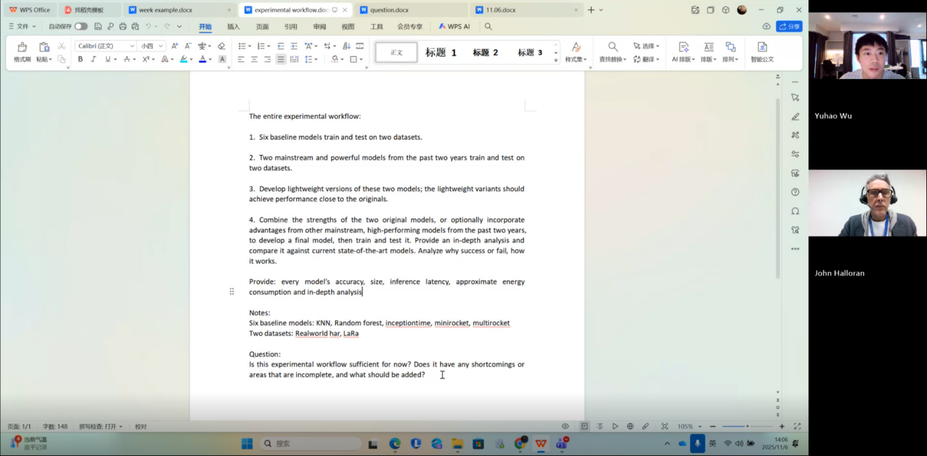
- I showed some templates for documenting the project process.
Me: Can I write these in my weekly project process document?
Answer: Yes, you can.
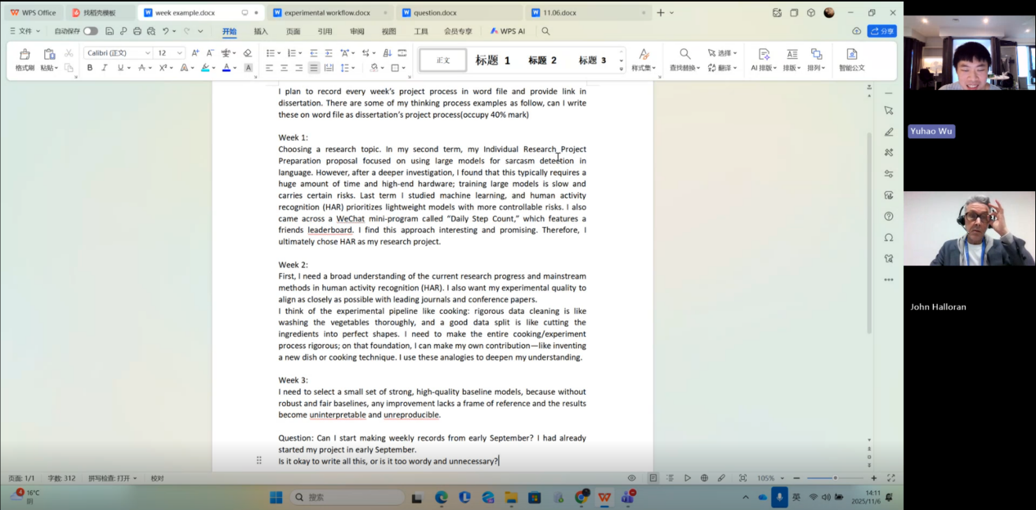

Questions asked; how questions were answered
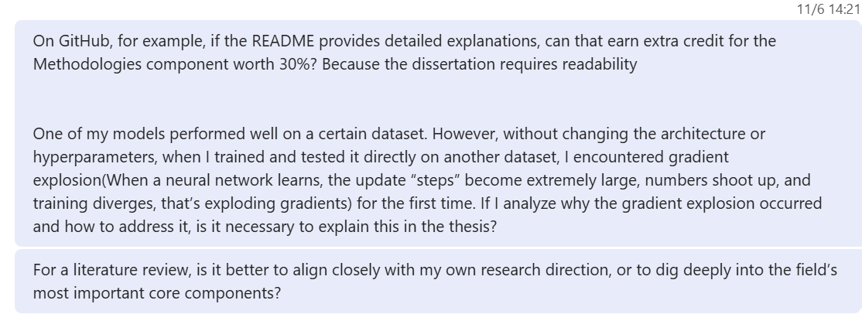
Answer
1. A GitHub project with good documentation is indeed something that deserves extra credit.
2. Yes, that is a good idea.
3. The literature review should cite those works that support your research direction. Therefore, you only need to focus on the most important core issues in the field and discuss them insofar as they are relevant to your own research direction.

Actions for next week
Combine different models and then design new ones.

Computing Project
WORK DONE
- The energy proxy analysis for the six models.
2. Wrote part of the literature review, up to the Classical Pipelines for HAR section.
3. Resolved the question of why rTsfNet achieves high accuracy on RealWorld but only moderate accuracy on LARa.
4. Solved the gradient explosion problem of rTsfNet on the LARa dataset.
5. Completed the training and testing of rTsfNet on both datasets.
6. Designed a lightweight version of rTsfNet.

Issues and challenges
1. The designed lightweight version of rTsfNet shows only moderate overall performance, so it may be necessary to continue designing new models.
2. When designing new models in the next stages, in which aspect—accuracy, model size, inference latency, or energy consumption—is it easier and more reasonable to achieve a breakthrough?
3. How can we combine the strengths of rTsfNet, DeepConvContext, or Transformer-based architectures to design a new model?

Actions for next week
1. Train and test DeepConvContext on the RealWorld and LARa datasets.
2. Design a new model by combining the strengths of rTsfNet, DeepConvContext, Transformers, and possibly other architectures.
3. Evaluate all current models along four dimensions: accuracy, model size, inference latency, and energy consumption.

Link to recording
Part 1
https://livecoventryac-my.sharepoint.com/:v:/g/personal/wuy176_uni_coventry_ac_uk/IQDQgUtnX7H8S5nIjf-DBdI9AXAuZgxV4o_bi6nxK-JEx5g?nav=eyJyZWZlcnJhbEluZm8iOnsicmVmZXJyYWxBcHAiOiJTdHJlYW1XZWJBcHAiLCJyZWZlcnJhbFZpZXciOiJTaGFyZURpYWxvZy1MaW5rIiwicmVmZXJyYWxBcHBQbGF0Zm9ybSI6IldlYiIsInJlZmVycmFsTW9kZSI6InZpZXcifX0%3D&e=mlAkoy

Part 2
https://livecoventryac-my.sharepoint.com/:v:/g/personal/wuy176_uni_coventry_ac_uk/IQDvIHkyDLBRRIG1edqIDwnPARBw7NTsB84ixW5SVZXcF28?nav=eyJyZWZlcnJhbEluZm8iOnsicmVmZXJyYWxBcHAiOiJTdHJlYW1XZWJBcHAiLCJyZWZlcnJhbFZpZXciOiJTaGFyZURpYWxvZy1MaW5rIiwicmVmZXJyYWxBcHBQbGF0Zm9ybSI6IldlYiIsInJlZmVycmFsTW9kZSI6InZpZXcifX0%3D&e=BeueYC

